1.Simple interest calculation.

import java.util.*;  
public class simpleinterset {  
 public static void main(String[] args) {  
 int p,y,roi;  
 char c;  
 System.*out*.println("enter the price amount ");  
 Scanner s=new Scanner(System.*in*);  
 p=s.nextInt();  
 System.*out*.println("enter no of yaers ");  
 y=s.nextInt();  
 System.*out*.println("are u senior citizien (s/n) ");  
 c=s.next().charAt(0);  
 if(c=='s'||c=='N'){  
 roi=p*y*12/100;  
 System.*out*.println("the rate of interset = "+roi);  
 } else if (c=='n'||c=='N') {  
 roi=p*y*10/100;  
 System.*out*.println("the rate of interset = "+roi);  
 }  
 else {  
 System.*out*.println("invalid input");  
 }

output.

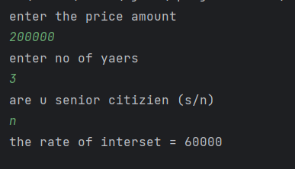

2. celsius to Fahrenheit.

import java.util.*;  
public class celsiustofahrenheit {  
 public static void main(String[] args) {  
 int c,f;  
 Scanner s=new Scanner(System.*in*);  
 System.*out*.println("enter degerre in celsius ");  
 c=s.nextInt();  
 f=c*9/5+32;  
 System.*out*.println("fahrenheit = "+f);  
  
  
 }  
}

output.

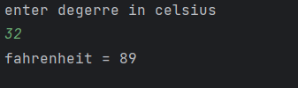

3.addtion of 2 no’s.

import java.util.*;  
public class addofnos {  
 public static void main(String[] args) {  
 int a,b,c;  
 Scanner s=new Scanner(System.*in*);  
 System.*out*.println("enter no 1 ");  
 a=s.nextInt();  
 System.*out*.println("enter no 2 ");  
 b=s.nextInt();  
 c=a+b;  
 System.*out*.println("sum = "+c);  
  
  
 }  
}

output.

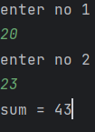

4.odd or even.

import java.util.*;  
public class oddoreven {  
 public static void main(String[] args) {  
 int a;  
 System.*out*.println("enter a number ");  
 Scanner s= new Scanner(System.*in*);  
 a=s.nextInt();  
 if(a%2==0){  
 System.*out*.println("even number");  
 }  
 else{  
 System.*out*.println("odd number");  
 }  
 }  
}

output.

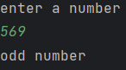

5.leap year not not.

import java.util.*;  
public class leapyear {  
 public static void main(String[] args) {  
 int year;  
 System.*out*.println("enter a year ");  
 Scanner s= new Scanner(System.*in*);  
 year=s.nextInt();  
 if((year%4==0) && ((year%400==0) || (year%100!= 0))){  
 System.*out*.println("leap year");  
 }  
 else{  
 System.*out*.println("not a leap yaer");  
 }  
 }  
}

output.

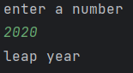

6.voting.

import java.util.*;  
public class voting {  
 public static void main(String[] args) {  
 int age;  
 System.*out*.println("enter a age ");  
 Scanner s= new Scanner(System.*in*);  
 age=s.nextInt();  
 if(age>=18){  
 System.*out*.println("you can vote");  
 }  
 else{  
 System.*out*.println("you cannot vote");  
 }  
 }  
}

output.

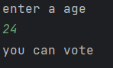

7.positive or negative

import java.util.*;  
public class postornega {  
 public static void main(String[] args) {  
 int n;  
 System.*out*.println("enter a number ");  
 Scanner s= new Scanner(System.*in*);  
 n=s.nextInt();  
 if(n>0){  
 System.*out*.println("postive");  
 }  
 else if(n==0){  
 System.*out*.println("neither odd nor even");  
 }  
 else{  
 System.*out*.println("negative");  
 }  
 }  
}

output.

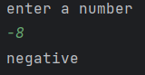

9.printing a string.

import java.util.*;  
public class printingstring {  
 public static void main(String[] args) {  
 String a;  
 Scanner s=new Scanner(System.*in*);  
 System.*out*.println("enter a string ");  
 a=s.nextLine();  
 System.*out*.println(a);  
  
  
 }  
}

output.

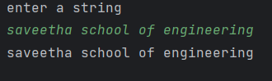

10.sum of series.

import java.util.*;  
public class sumofseries {  
 public static void main(String[] args) {  
 int a,sum=0, i;  
 System.*out*.println("enter number ");  
 Scanner s = new Scanner(System.*in*);  
 a = s.nextInt();  
 for (i = 1; i <= a; i++) {  
 sum+=i;  
 }  
 System.*out*.println(sum);  
 }  
}

output.

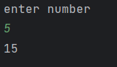

11.factorial.

import java.util.*;  
public class fact {  
 public static void main(String[] args) {  
 int a, fact = 1, i;  
 System.*out*.println("enter number ");  
 Scanner s = new Scanner(System.*in*);  
 a = s.nextInt();  
 for (i = 1; i <= a; i++) {  
 fact = fact * i;  
 }  
 System.*out*.println(fact);  
 }  
}

output.

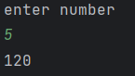

12.fibonacci.

import java.util.*;  
public class fibo {  
 public static void main(String[] args) {  
 int a,f1=0,f2=1,f3,i;  
 System.*out*.println("enter number ");  
 Scanner s=new Scanner(System.*in*);  
 a=s.nextInt();  
 System.*out*.println(f1);  
 System.*out*.println (f2) ;  
 for (i=0;i<a;i++){  
 f3=f1+f2 ;  
 f1=f2 ;  
 f2=f3 ;  
 System.*out*.println (f3);}  
  
}}

output.

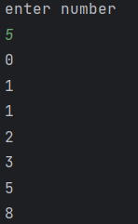

13.Armstrong.

import java.util.Scanner;  
public class armstrong {  
 public static void main(String[] args) {  
 System.*out*.println("enter a number : ");  
 Scanner num = new Scanner(System.*in*);  
 int number = num.nextInt();  
 int n=number;  
 int res=0,temp;  
 while(n!=0){  
 temp=n%10;  
 res+=temp*temp*temp;  
 n=n/10;  
 }  
 if (res == number)  
 System.*out*.println("Armstorng number ");  
 else  
 System.*out*.println("Not armstorng number ");  
  
  
 }  
}

output.

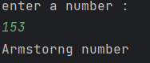

14(a).reverse integer.

import java.util.Scanner;  
public class reverse_int {  
 public static void main(String[] args) {  
 System.*out*.println("enter a number : ");  
 Scanner num = new Scanner(System.*in*);  
 int n = num.nextInt();  
  
 int rev=0,temp;  
 while(n!=0){  
 temp=n%10;  
 rev=rev*10+temp;  
 n=n/10;  
 }  
 System.*out*.println("reverse = "+rev);  
 }  
}

output.

